GIT
cd /d D:\Ring3

git status
git pull --rebase origin main
git add .gitignore
git commit -m "Update gitignore"
git push -u origin main
git push -u origin main –force

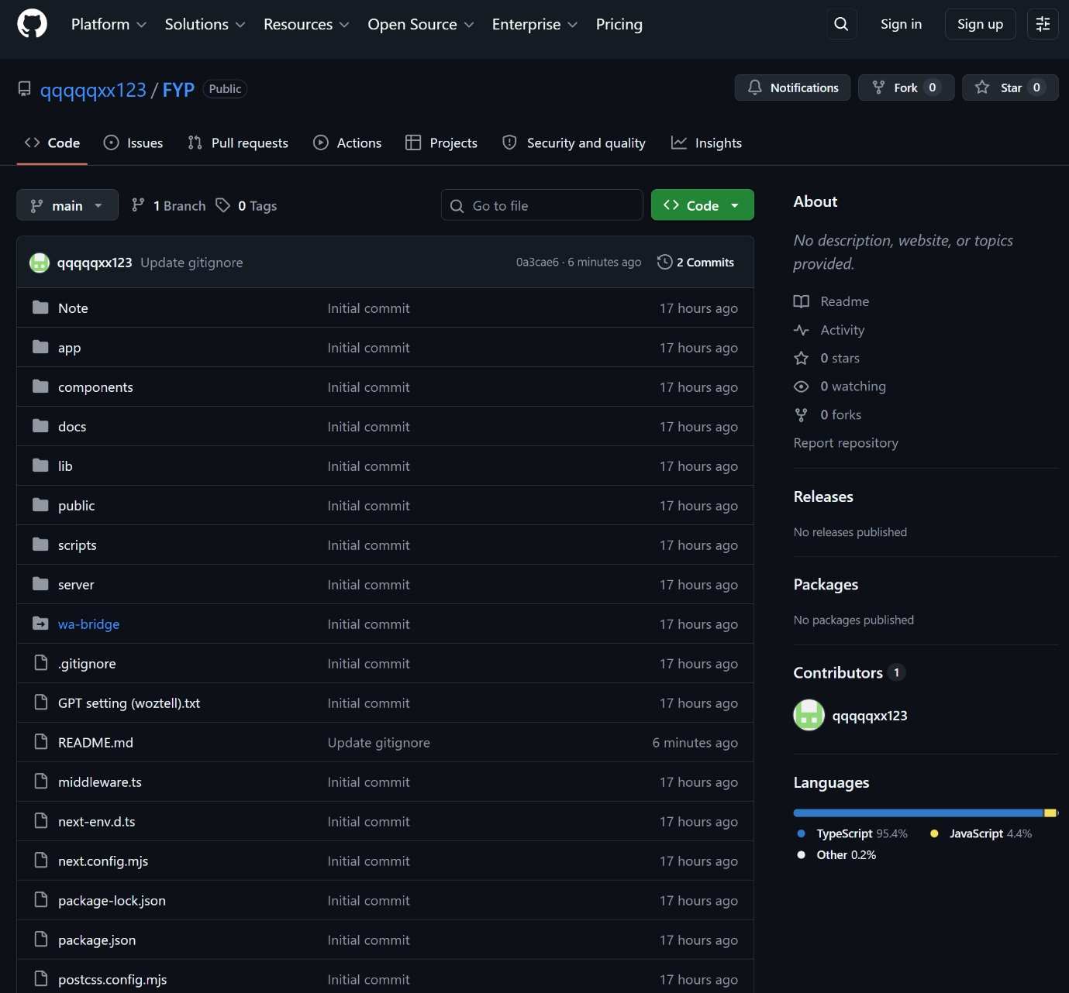

VPS
ssh root@187.127.111.108
P@3514

Install requirement
apt update && apt upgrade -y
apt install -y git nginx curl
curl -fsSL https://deb.nodesource.com/setup_20.x | bash -
apt install -y nodejs
npm install -g pm2

Clone from git
cd /var/www
git clone https://github.com/qqqqqxx123/FYP
cd FYP
npm ci

